

press release no. 1
(English translation)

TTG TRAVEL EXPERIENCE 2024, TOURISM IN THE NAME OF AUTHENTICITY

The Italian Exhibition Group event, taking place at Rimini Expo Centre from 9 to 11 October, will be inspired by Veritas, for tourism beyond clichés. Running parallel, the second edition of InOut|The Contract Community, the event dedicated to out-of-home hospitality

- Among the new additions this year, a spotlight on nautical tourism. High-end tourism will feature in the recurring Luxury Event by TTG

- The encounter between tourist supply and demand expands its international reach with The World Programme

www.ttgexpo.it

Rimini, 9-11 October 2024 – All set to go for the 61st edition of TTG Travel Experience, organised by Italian Exhibition Group from 9 to 11 October at Rimini Expo Centre, reconfirming itself the Italian reference event for the promotion of world tourism. More than 1,000 buyers from 75 countries expected, with a total of 2,700 exhibitors across 26 pavilions. The theme of this edition will be Veritas, because more than ever before, today’s industry needs to rely on truthful stories about destinations, real trend data and scientifically verifiable market analyses, in a time in which storytelling is artificially created, fake news is rampant, and reviews are often misleading.
Faced with ever more enlightened travellers, the market is seeking to launch a new era in an industry that recorded 790 million tourists worldwide in the first 7 months of 2024, 11% more than in the same period in 2023 (source: World Tourism Barometer – UN Tourism).
Building on last year's success, InOut|The Contract Community will be held in conjunction with TTG, the event is dedicated to the contract community, both indoor and outdoor, bringing together all the trends and developments in the world of hospitality supplies, from construction to interior design.

A SPOTLIGHT ON NAUTICAL TOURISM AND NEW LUXURY TRENDS
This edition of TTG Travel Experience gives additional scope to nautical tourism, a rapidly growing sector that just last year logged a 130% increase in bookings. The categories involved in TTG range from nautical charters to cruises, from tourist ports to parks to coastal reserves, also involving skippers, courses for pleasure boats, diving, boat excursions and trade associations.
Luxury tourism is in excellent health, considering that in Italy alone it represents 25% of the overall tourism industry. TTG has intercepted this trend to the point of dedicating an actual event to this sector, now in its second edition. On October 8, the Grand Hotel in Rimini, will host Luxury Event by TTG, the business meeting with leading qualified international buyers, to encourage one-to-one meetings between high-end tourism operators.

“THE WORLD” PROGRAMME: BUSINESS MATCHES ARE SPREADING THEIR HORIZIONS
With a large community of buyers from all over the world, TTG Travel Experience has launched The World Programme, reserved for foreign operators and tourism promotion bodies to facilitate meetings with numerous Italian and international buyers. An opportune initiative to discover future tourism trends, new international tourist destinations and access the most important business opportunities with the main global stakeholders.

AROUND THE WORLD IN THREE DAYS
TTG Travel Experience is a journey around the world within the confines of the expo centre. The 2024 edition occupies three macro exhibition areas: the Italy area, where all the national tourist offerings are concentrated, the Global Village, the space dedicated to tour operators and products and services for tourism, and lastly, The World, bringing together all the foreign destinations. In addition to these, there are the special projects, which include the Nautical Tourism Area, the Next Start-up Area, where over 55 start-ups and innovation pioneers will discuss projects and exchange ideas in the tourism industry; then there is the African Village, a collective area that gathers operators specialised in African destinations, and the BeActive Area, created to promote and advocate sports tourism and is closely connected to the slow and nature tourism segments. The events will take place in nine Arenas where experts, market analysts and the most important players in the industry will discuss trends and prospects for the professionals attending the trade fair. Under the umbrella of Think Future, they will find a rich line up of events, talks, seminars and round tables for professional tourism updating. During the course of the events, Vision+25 by TTG will be presented - a document collecting the five deep trends in consumer tourism and upcoming scenarios.

ABOUT TTG TRAVEL EXPERIENCE
Event: international trade show; organizer: Italian Exhibition Group SpA; recurrence: annual; edition: 61st; open to: reserved exclusively for trade professionals; website: www.ttgexpo.it - #ttgexpo

ABOUT: INOUT | THE CONTRACT COMMUNITY
Event: international trade show; organizer: Italian Exhibition Group SpA; recurrence: annual; edition: 2nd edition of INOUT including SIA, SUN, SUPERFACES, GREENSCAPE; open to: reserved exclusively for trade professionals; website: www.inoutexpo.it #inoutexpo

IEG PRESS CONTACT, TTG TRAVEL EXPERIENCE
Elisabetta Vitali, head of corporate communication & media relations; Marco Forcellini, Pier Francesco Bellini, press office manager media@iegexpo.it

MEDIA AGENCY TTG TRAVEL EXPERIENCE: Mind The Pop
Martina Vacca: martina@mindthepop.it, mob. +39 339 748 4994; Fabrizio Raimondi: fabrizio@mindthepop.it, mob. +39 335 389 848; Benedetto Colli: benedetto@mindthepop.it, mob. 380 371 2272; Stefano Chiossi: stefano@mindthepop.it, mob. + 39 388 739 4358.

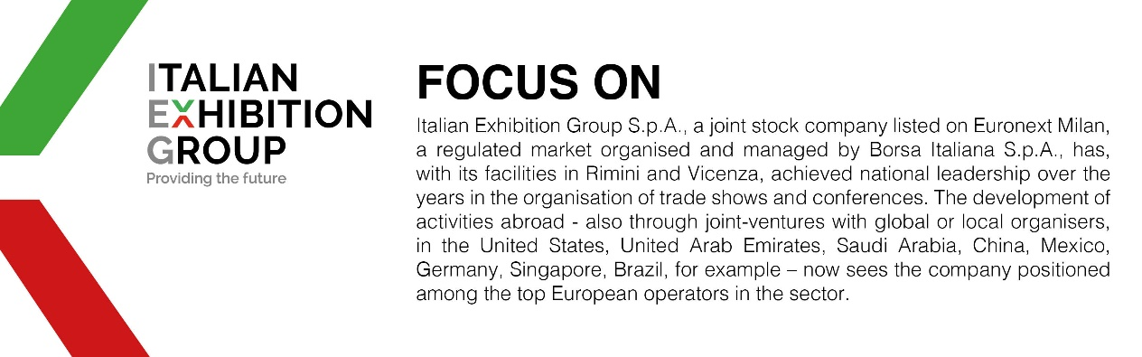

This press release contains forecast elements and estimates that reflect the management’s current opinions (“forward-looking statements”), particularly regarding future management performance, realization of investments, cash flow trends and the evolution of the financial structure. For their very nature, forward-looking statements have a component of risk and uncertainty, as they depend on the occurrence of future events. The effective results may differ (even significantly) from those announced, due to numerous factors, including, only by way of example: food service market and tourist flow trends in Italy, gold and jewellery market trends, green economy market trends; the evolution of raw material prices; general macroeconomic conditions; geopolitical factors and evolutions in the legislative framework. Moreover, the information contained in this release does not claim to be complete, and has not been verified by independent third parties. Forecasts, estimates and objectives contained herein are based on the information available to the Company as at the date of this release.

